**Installation**

**Step 1: Installing Visual Studio Code**

Visual Studio Code (VS Code) is a free development environment from Microsoft. VS Code is a text editor that allows the installation of various (free) extensions to support development of software with different programming languages.

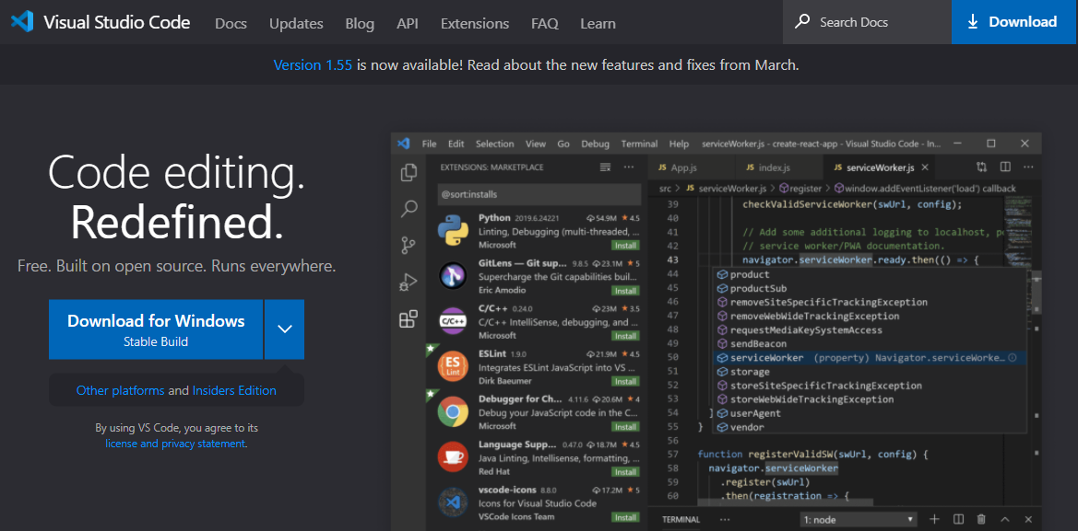VS Code Download: <https://code.visualstudio.com/>

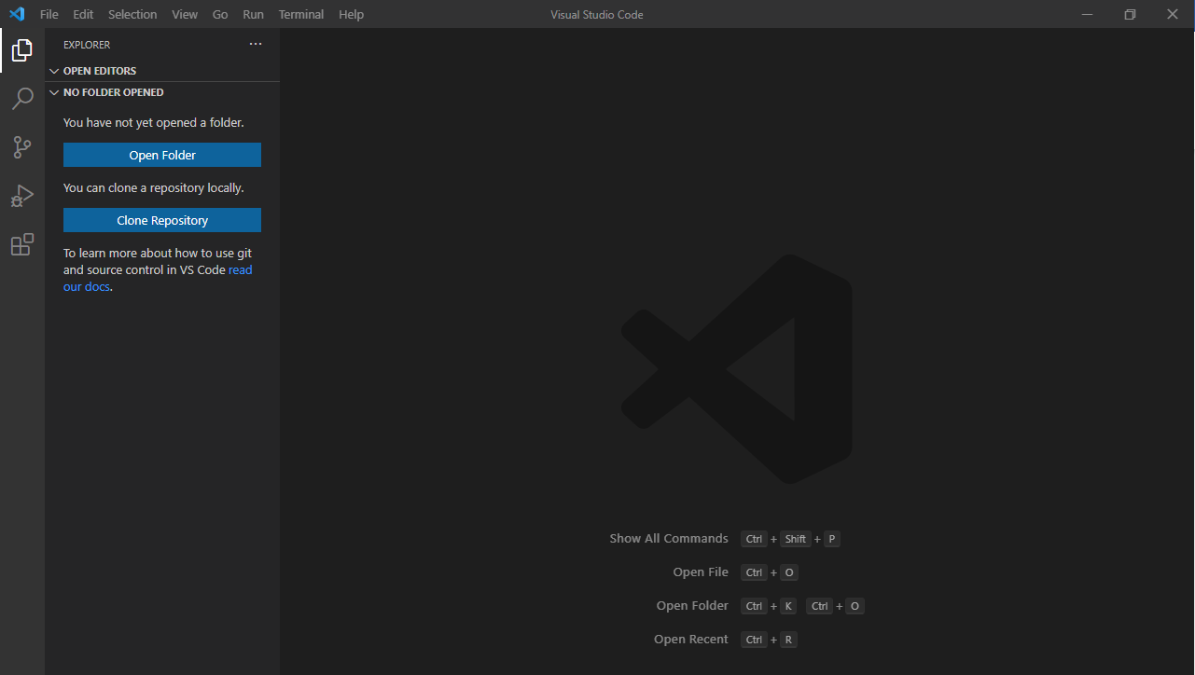After the download, run the setup and follow the steps in the installation program. After successful installation run VS Code and you will see the main page.

**Step 2: Installing the extension**

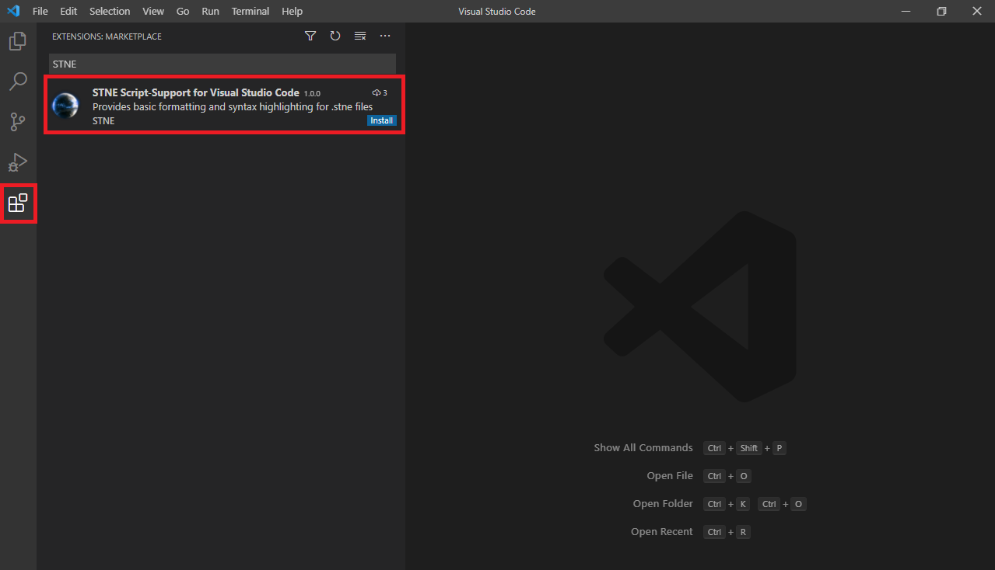Installing an extension for VS Code can be done in different ways. Using the 5th entry in the left menu bar (Extensions) you will open the extension overview. There you can find a search field where you can search for “STNE”. To install the extension, click on „Install“. Alternatively, you can use the VS Code Marketplace to download the extension from the website: <https://marketplace.visualstudio.com/items?itemName=STNE.stnescript-support>

After installing, you can open a detail page with a click on the extension. Here you can find the option „Set File Icon Theme“. When activating this function, .stne files will be displayed with a small custom icon in the explorer. This is only a function for improved aesthetics and can be skipped without any problem.

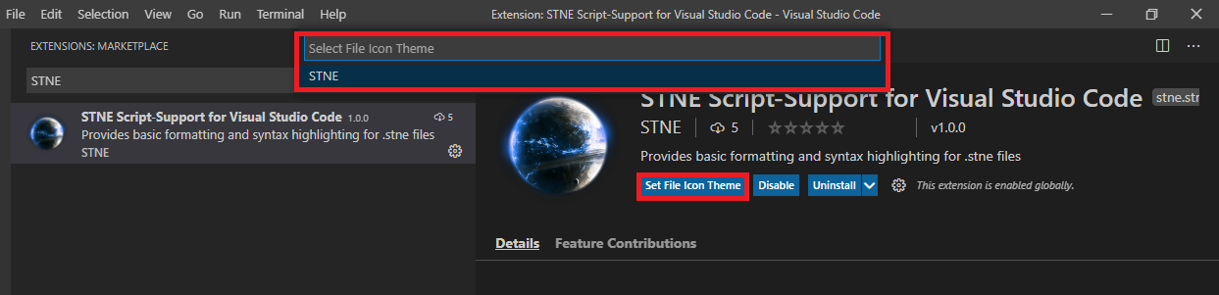To activate the file icons, click on „Set File Icon Theme“. In the following window, choose „STNE“ as your icon theme. Alternatively, you can change the file icon theme using the VS Code settings menu at any later date.

**Testing the extension**

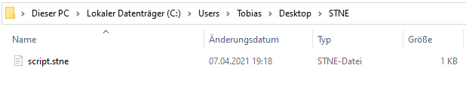To see the extension working, you have to open a .stne file that contains some STNE scripting code. This can simply be done by creating a folder somewhere on your local machine (e.g. „C:/Users/Me/Desktop/STNE“). Using any text editor such as Notepad or Wordpad, create a new .txt file. Copy some STNE scripting code into the file and change the file ending to .stne.

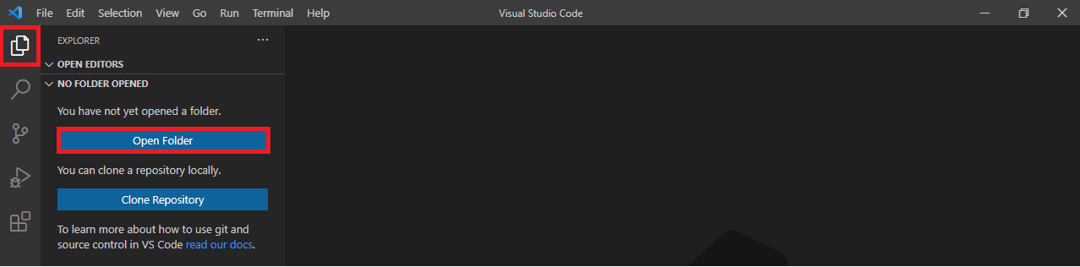Now you can use VS Code to open the folder and the file. Simply use the integrated file explorer and use “Open Folder” to search for your folder with the script file.

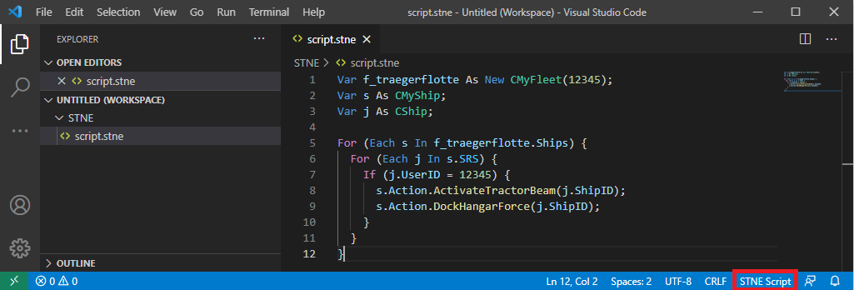Open the .stne file. You will see that different elements of the scripting code are now highlighted. In the bottom menu bar, you can also see that the programming language of the file is now detected as “STNE Script”.

**What is possible with the extension?**

Currently, the extension provides three basic functions to support STNE scripting in VS Code.

**Function 1: Syntax highlight**

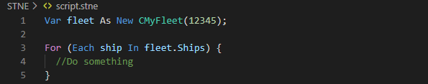The most obvious function is the syntax highlight of different elements in the STNE scripting code. Definitions, methods, instructions and more are highlighted using the currently active VS Code color theme.

**Function 2: Auto-Formatting**

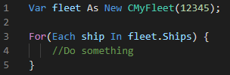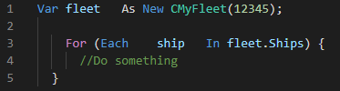Using the key combination SHIFT + ALT + F (default setting), you can format the currently opened document in VS Code . Any unnecessary whitespaces and empty lines are removed and the intendation of each line is corrected.

**Function 3: Auto completition**

Another useful function is the suggestion of types, attributes and methods. The completition and suggestion is triggered whenever an „As ” or “As New ” is written or whenever you try to call a member (method or attribute) on an object using “object.”.

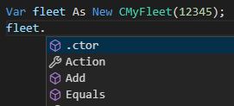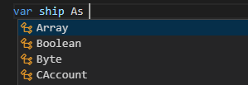

**Additional information**

The extension was developed by

* []U.C.W[] Scorga Empire (DE1-34108)
* Admin MEO
* Orion (DE1-71164)

This extension is in a very early stage of development. I know that there might still be some mistakes that can cause incorrect highlighting or formatting. Please keep in mind that this is kind of a hobby project. The extension was not developed as an official STNE project. However, I decided to publish it regardless to all players. I hope that at least some people will benefit from the extension. I would like to point out that due to time restrictions I can and will not develop this as active as you might expect.

If you found an error, please get in touch with me. If you got interested in the topic and you want to contribute to the development of the extension, please do get in touch as well.

**Contact: DE1-71164 or via Discord Orion#1733**